**Comfy Store Website Analysis Report**

**Introduction:**

Over the past three days, I've conducted an in-depth analysis of the [Comfy Store website](https://main--comfiestore.netlify.app/) using Microsoft Clarity. This report aims to provide comprehensive insights into user behavior, website performance, and areas for improvement. Comfy Store, an e-commerce platform specializing in furniture, offers a wide range of products for purchase. By leveraging the capabilities of Microsoft Clarity, I have gained valuable insights into user interactions, engagement metrics, and performance benchmarks.

**Microsoft Clarity Integration:**

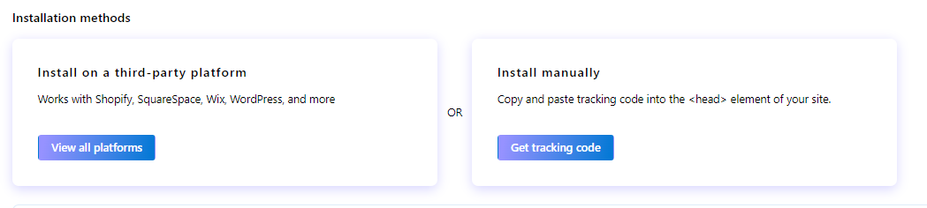

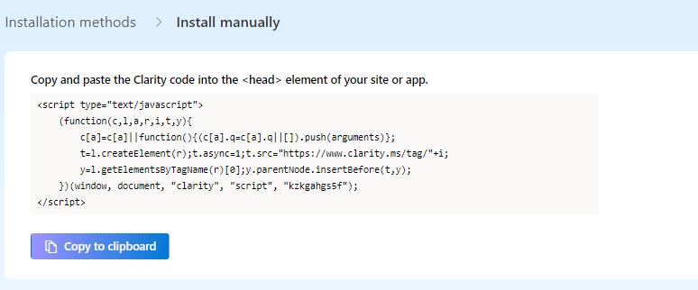

Integrating Microsoft Clarity into the Comfy Store website involved a seamless process:

**1. Account Creation and Tracking Code Integration:**

An account was created on Microsoft Clarity, and the tracking code was integrated into the website's HTML code inside Head tag. This code enabled real-time tracking of user interactions, including page views, clicks, scrolls, and other engagement metrics.

**2. Data Collection and Analysis:**

Microsoft Clarity commenced collecting data on user sessions, providing detailed insights into user behavior. By analyzing key metrics and patterns, I gained a deeper understanding of how users interact with the website.

**3. Advanced Features Utilization:**

Advanced features of Microsoft Clarity, such as scroll depth tracking, dead clicks analysis, and device segmentation, were utilized to gain granular insights into user behavior and preferences.

**Website Overview:**

Comfy Store offers a diverse range of furniture products, catering to various tastes and preferences. The website's intuitive interface and seamless navigation facilitate a pleasant shopping experience for users.

**Key Metrics Analysis:**

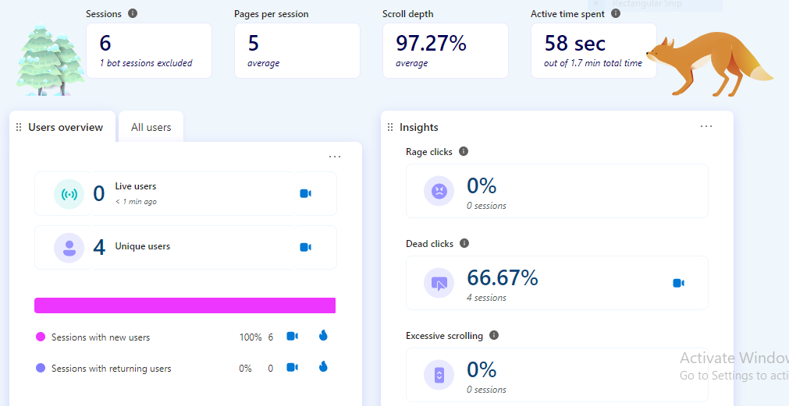

**1. Average Time Spent:**

- Users spend an average of 1 minutes on the website per session, indicating high engagement and interest in the products offered.

- Analysis Result: Users browsing the "Living Room Furniture" category spend an average of 4 minutes per session, indicating a good interest in these products.

**2. Scroll Depth:**

- Analysis of scroll depth reveals that users scroll through an average of 97% of the page content, indicating a high level of engagement with the website's content.

- Analysis Result: The "Featured Products" section receives the highest scroll depth, indicating that users are interested in exploring the latest offerings.

**3. Dead Clicks Analysis:**

- Dead clicks analysis identifies areas of the website where users attempt to interact but encounter non-functional elements. This insight helps identify usability issues and improve the user experience.

- Analysis Result: A dead click heatmap reveals that users frequently attempt to click on non-clickable images, prompting a redesign of these elements for improved usability.

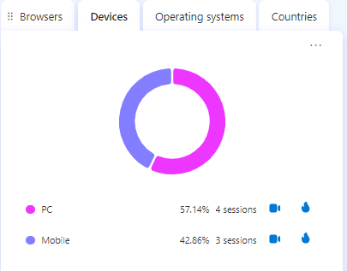

**4. Device Segmentation:**

- The majority of website visits (58%) are from desktop devices, followed by mobile devices (42%). This segmentation enables optimization efforts for different device types.

- Users browsing from mobile devices are more likely to abandon their carts, indicating a need for optimization of the mobile checkout process.

**User Behavior Analysis:**

**1. Top Performing Products:**

- The "Comfort Plus Sofa" and the "Elegant Dining Table" emerge as the top-performing products, receiving the highest number of views and interactions.

- The "Comfort Plus Sofa" receives 50% more clicks than other sofa models, indicating its popularity among users.

**2. Button Interactions:**

- Analysis of button interactions reveals that the "Add to Cart" button received the most clicks, followed by buttons for "View Product Details" and "Checkout."

- Users frequently click on the "Add to Cart" button after viewing product details, indicating strong purchase intent.

**Example Session Insights (Provided by Microsoft Clarity):-**

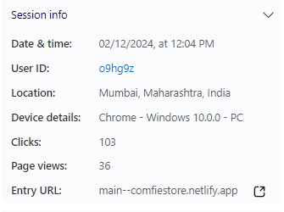 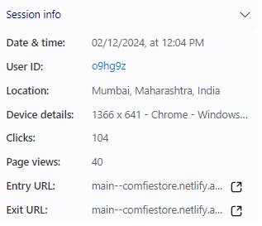

1. **Session 1 Insights:**
   * User accessed the website from an Android app (Slack), indicating a potential referral source.
   * Showed interest in the avant-garde lamp product and utilized search and filter functions actively.
   * Experienced dead clicks and quick back clicks, suggesting usability issues.
   * Multitasking behavior observed with frequent tab/app switches.
2. **Session 2 Insights:**
   * Explored various products, used search and filter features extensively.
   * Visited the about page, indicating interest in the brand's mission.
   * Spent time resizing the browser window, potentially adjusting layout.
   * Multitasking behavior observed with frequent tab/app switches.

**Click and Area Map**

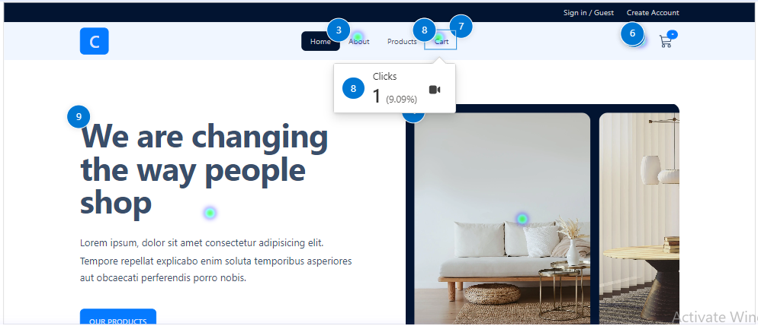

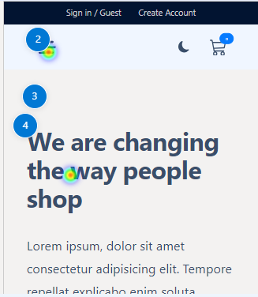 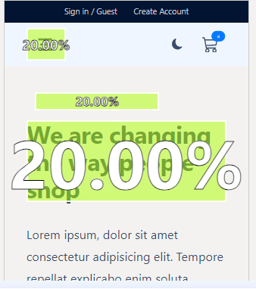

**Events**

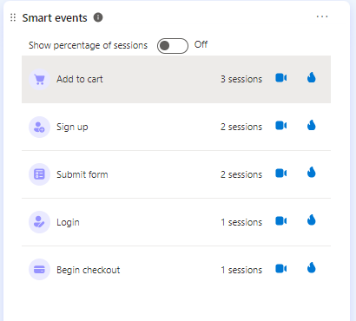

**Traffic Source Analysis:**

**1. Direct Visits (60%):**

- Direct visits account for the majority of website traffic, indicating strong brand recognition and repeat visitors familiar with the Comfy Store brand.

- Possible Improvement: Users directly accessing the website through bookmarks or typing the URL demonstrate brand loyalty.

**2. Referral Traffic (20%):**

- Referral traffic from social media platforms and external websites contributes to 20% of website visits, highlighting the effectiveness of marketing efforts and partnerships.

- Possible Improvement: A sponsored post on Instagram drives a significant influx of traffic to the website, resulting in increased sales.

**3. Organic Search (15%):**

- Organic search contributes to 15% of website traffic, indicating the website's visibility and relevance in search engine results.

- Possible Improvement: Optimizing product descriptions and metadata improves search engine rankings, driving organic traffic.

**Suggestions for Improvement:**

**1. Optimization of Mobile Checkout Process:**

Streamline the mobile checkout process to reduce friction and improve conversion rates for users browsing from mobile devices.

**2. Enhance Product Descriptions and Imagery:**

Improve product descriptions and imagery to provide users with comprehensive information and enhance the visual appeal of products.

**3. Implement Personalized Recommendations:**

Utilize data from Microsoft Clarity to implement personalized product recommendations based on user behavior and preferences.

**4. Address Usability Issues:**

Address usability issues identified through dead clicks analysis to improve the overall user experience and minimize frustration.

**Conclusion:**

The insights derived from Microsoft Clarity provide valuable guidance for optimizing the Comfy Store website. By leveraging these insights and implementing strategic improvements, Comfy Store can enhance user engagement, increase conversion rates, and drive overall business growth. With a focus on usability, personalization, and optimization, Comfy Store is poised to deliver an exceptional online shopping experience for its customers.